TeVi - GLobal Terrorism Visualizer

-User Guide-

1. The presentation Page

Here you can find details about the visualizer, by scrolling, or you can press “Explore in order to perceed to the next page”

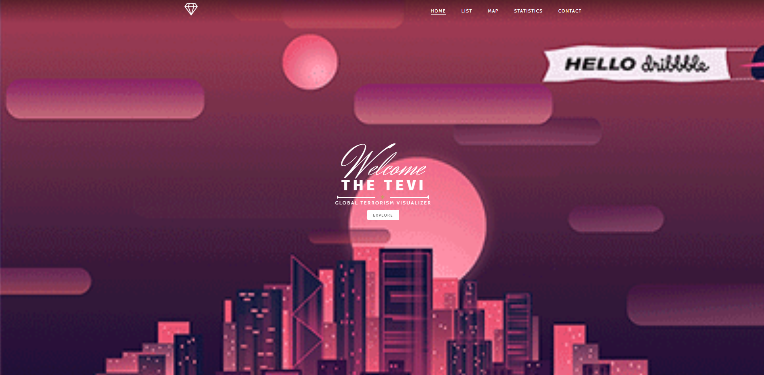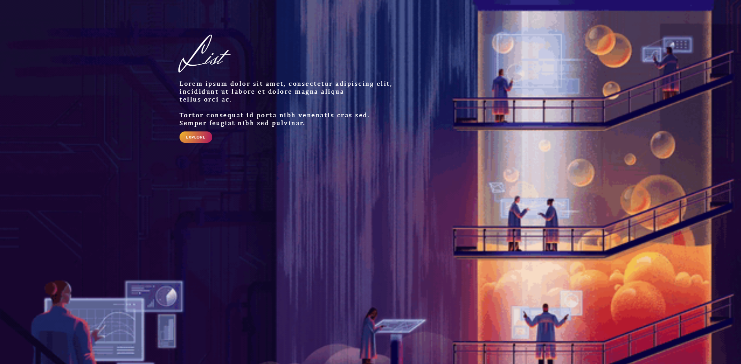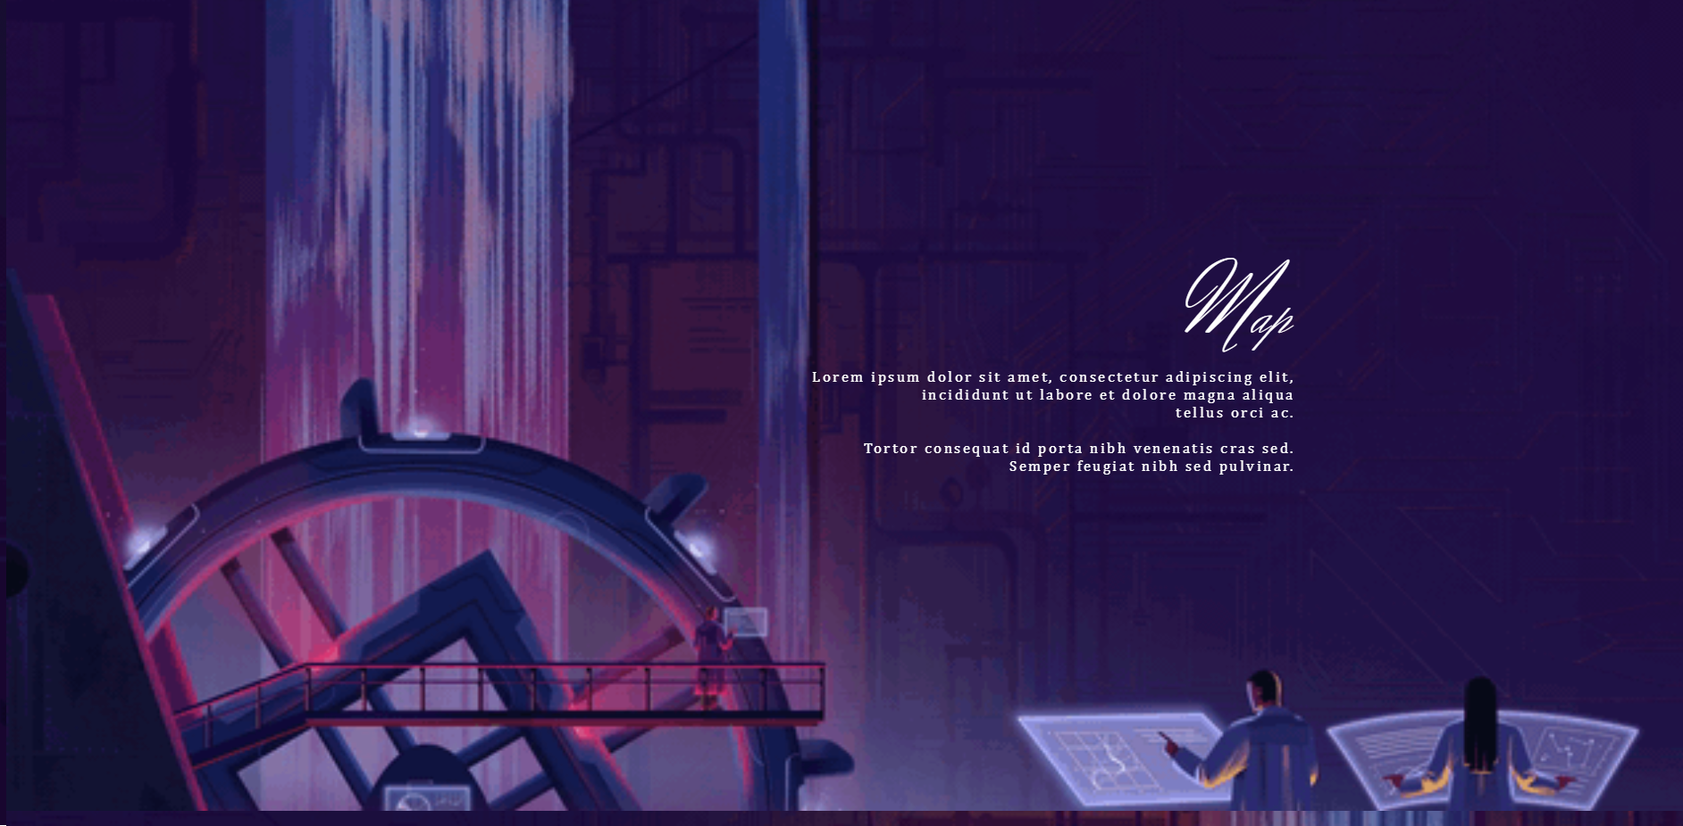

2.The visualization modes presentation

Here you can read about the multiple data representations. After you are done, press thr diamond-shaped button, to go to the application main screen

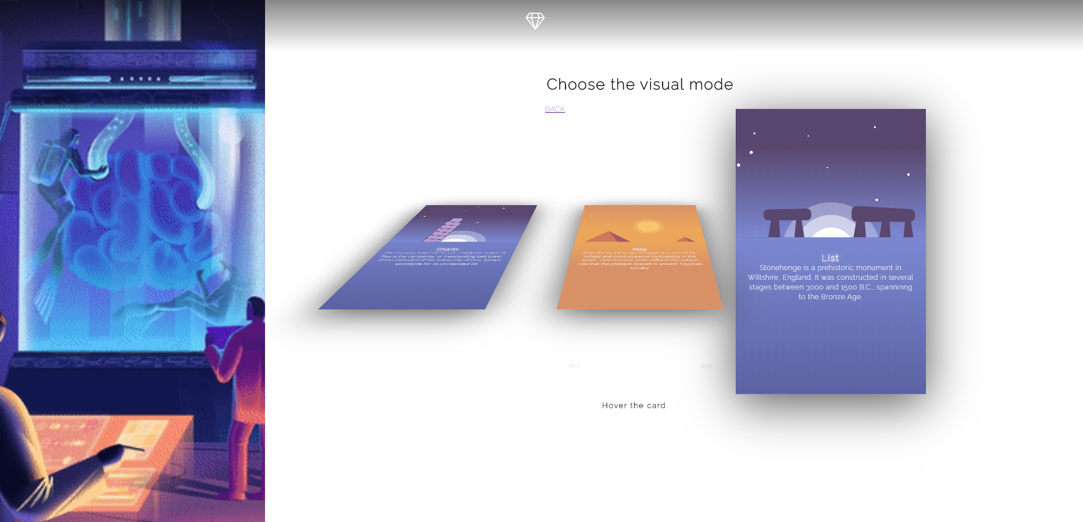

3. The main screen allows

3.1 Data Filtering

Choose a filter type from the current dropdown and press submit, then

another dropdown will appear, containing possible filter values for the filter you’ve just picked. For some filters, you can also specify an interval, if the “Between” button is present. After all the filters are added, press search.

3.2 Data Visualization

After you’ve picked your filters, you may pick your visualization method by pressing one of “map”, “pie chart”, “scatter chart”, “bar chart”, “chart”, “csv”, “png”

3.4 Data Save

You can choose to save data either as csv, png or svg by clicking hte download buttons.